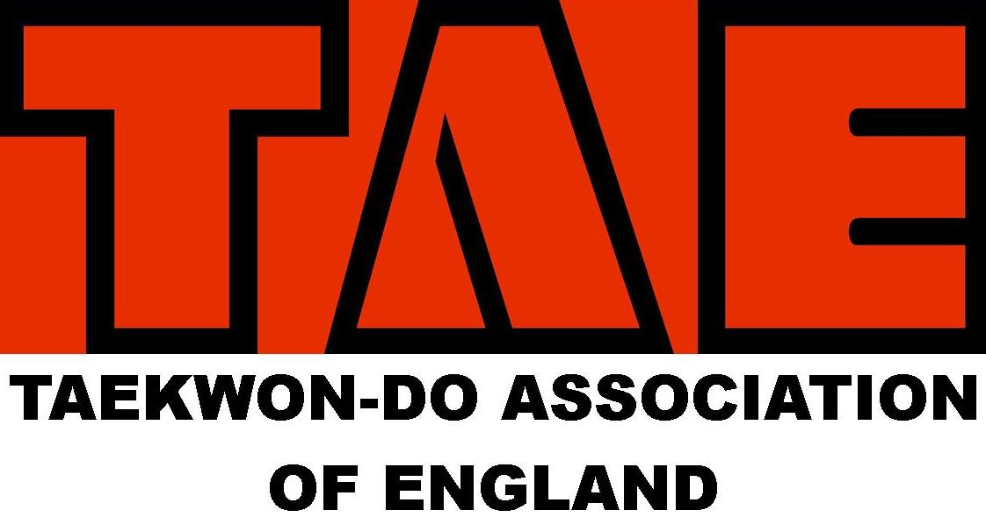

SOCIAL MEDIA POLICY
Policy overview and purpose

Social media is changing the way we communicate.

This policy has been developed to inform our community about using social media so people feel enabled to participate, while being mindful of their responsibilities and obligations. In particular, this policy provides practical guidance allowing all parties to benefit from the use of social media, while minimising potential risks and protecting those involved.

This policy assists to establish a culture of openness, trust and integrity in all online activities related to

This policy contains Taekwon do Association of England (TAE) guidelines for the TAE community to engage in social media use. It also includes details of breaches of the policy.

In circumstances where guidance about social media issues has not been given in this policy, we suggest you use common sense or seek out advice from those who have approved this policy.

Underlying principles

This policy complements the TAE’s core values:

To use Taekwon do as a tool to develop true martial artists, where the physical aspects of "Tae" and "Kwon", are taught and promoted with equal emphasis alongside the mental aspects of "Do"

We aim to achieve this by creating a culture in our schools of true martial
art philosophy, based upon the principles inherited by the founder of Tae Kwon do, the late Grand Master General Choi Hong Hi.

The Committee are responsible for all matters related to this policy.

Coverage

This policy applies to all persons who are involved with the activities of TAE, whether they are in a paid or unpaid/voluntary capacity and including:

- members, including life members of the TAE
- persons appointed or elected to boards, committees and sub-committees;
- employees of TAE;
- members of the TAE Committee;
- support personnel, including managers, physiotherapists, psychologists, masseurs, sport trainers and others;
- coaches and assistant coaches;
- Students;
- referees, umpires and other officials;

Scope

Social media refers to any online tools or functions that allow people to communicate and/or share content via the internet.

This social media policy applies to platforms including, but not limited to:
- Social networking sites (e.g. Facebook, Twitter, LinkedIn, Google+, Pinterest, Yammer, Instagram, tik tok etc)
- Video and photo sharing websites or apps (e.g. YouTube, Vimeo, Instagram, Flickr, Vine, etc)
- Blogs and micro-blogging platforms (e.g. Tumblr, Wordpress, Blogger, etc)
- Review sites (e.g. Yelp, Urban Spoon, etc)
- Live broadcasting apps (e.g. Periscope, Meerkat, Facebook Mentions, etc)
- Podcasting (e.g. iTunes, Stitcher, Sound cloud, etc)
- Geo-spatial tagging (e.g. Foursquare, etc)
- Online encyclopaedias (e.g. Wikipedia, etc)
- Instant messaging (e.g. SMS, Skype, Snapchat, WhatsApp, Viber, etc)
- Online multiplayer gaming platforms (e.g. World of Warcraft, Second life, Xbox Live, etc)
- Online voting or polls
- Public and private online forums and discussion boards
- Any other online technologies that allow individual users to upload and share content.

This policy is applicable when using social media as:

- an officially designated individual representing TAE on social media; and

- if you are posting content on social media in relation to TAE that might affect the association’s business, products, services, events, sponsors, members or reputation.

NOTE: This policy does not apply to the personal use of social media where it is not related to or there is no reference to TAE or its business, competitions, teams, participants, products, services, events, sponsors, members or reputation. However, any misuse by you of social media in a manner that does not directly refer to TAE may still be regulated by other policies, rules or regulations of TAE.

Using social media in an official capacity

You must be authorised by the committee before engaging in social media as a representative of TAE.

As a part of TAE’s, community you are an extension of the TAE brand.

As such, the boundaries between when you are representing yourself and when you are representing TAE can often be blurred. This becomes even more of an issue as you increase your profile or position within TAE. Therefore it is important that you represent both yourself and TAE appropriately online at all times.

Guidelines

You must adhere to the following guidelines when using social media related to TAE or its business, products, competitions, teams, participants, services, events, sponsors, members or reputation.

Use common sense
Whenever you are unsure as to whether or not the content you wish to share is appropriate, seek advice from others before doing so or refrain from sharing the content to be on the safe side.

When using social media, the lines between public and private, personal and professional, may be blurred. Remember, you are an ambassador for TAE.

Protecting your privacy
Be smart about protecting yourself and your privacy.

When posting content online there is potential for that content to become publicly available through a variety of means, even if it was intended to be shared privately. Therefore, you should refrain from posting any content online that you would not be happy for anyone to see, even if you feel confident that a particular individual would never see it.

Where possible, privacy settings on social media platforms should be set to limit access. You should also be cautious about disclosing your personal details.

Honesty
Your honesty—or dishonesty—may be quickly noticed in the social media environment. Do not say anything that is dishonest, untrue or misleading. If you are unsure, check the source and the facts before uploading or posting anything. TAE recommends erring on the side of caution – if in doubt, do not post or upload.

Do not post anonymously, using pseudonyms or false screen names. Be transparent and honest. Use your real name, be clear about who you are and identify any affiliations you have.

If you have a vested interest in something you are discussing, point it out. If you make an endorsement or recommendation about something you are affiliated with, or have a close relationship with, you must disclose that affiliation.

The web is not anonymous. You should assume that all information posted online can be traced back to you. You are accountable for your actions both on and offline, including the information you post via your personal social media accounts.

Use of disclaimers
Wherever practical, include a prominent disclaimer stating who you work for or are affiliated with (e.g. member of TAE) and that anything you publish is your personal opinion and that you are not speaking officially. This is good practice and is encouraged, but don't count on it to avoid trouble -– it may not have legal effect.

Reasonable use
If you are an employee of TAE, you must ensure that your personal use of social media does not interfere with your work commitments or productivity.
Respect confidentiality and sensitivity
When using social media, you must maintain the privacy of TAE’s confidential information. This includes information that is not publicly accessible, widely known, or not expected to be shared outside of TAE

Remember, if you are online, you are on the record—much of the content posted online is public and searchable.

Within the scope of your authorisation by TAE, it is perfectly acceptable to talk about TAE and have a dialogue with the community, but it is not okay to publish confidential information of TAE. Confidential information includes things such as details about litigation, unreleased product information and unpublished details about TAE: e.g. team, coaching practices, financial information .

When using social media you should be considerate to others and should not post information when you have been asked not to, or where consent has not been sought and given. You must also remove information about another person if that person asks you to do so.

Permission should always be sought if the use or publication of information is not incidental, but directly related to an individual. This is particularly relevant to publishing any information regarding minors. In such circumstances, parental or guardian consent is mandatory.

Gaining permission when publishing a person’s identifiable image
You must obtain express permission from an individual to use a direct, clearly identifiable image of that person.

You should also refrain from posting any information or photos of a sensitive nature. This could include accidents, incidents or controversial behaviour.

In every instance, you need to have consent of the owner of copyright in the image.

Complying with applicable laws
Do not post or link to content that contains illegal or indecent content, including defamatory, vilifying or misleading and deceptive content.

Abiding by copyright laws
It is critical that you comply with the laws governing copyright in relation to material owned by others and <<TAE>>’s own copyrights and brands.

You should never quote or use more than short excerpts of someone else's work, and you should always attribute such work to the original author/source. It is good practice to link to others' work rather than reproduce it.

Discrimination, sexual harassment and bullying
The public in general, and TAE's members, reflect a diverse set of customs, values and points of view.

You must not post any material that is offensive, harassing, discriminatory, embarrassing, intimidating, sexually explicit, bullying, hateful, racist, sexist or otherwise inappropriate.

When using social media you may also be bound by TAE’s values and Anti-Discrimination, Harassment and Bullying Policy.

Avoiding controversial issues
Within the scope of your authorisation by TAE, if you see misrepresentations made about TAE in the media, you may point that out to the relevant authority in TAE. Always do so with respect and with the facts. If you speak about others, make sure what you say is based on fact and does not discredit or belittle that party.

Dealing with mistakes
If TAE makes an error while posting on social media, be up front about the mistake and address it quickly. If you choose to modify an earlier post, make it clear that you have done so. If someone accuses TAEof posting something improper (such as their copyrighted material or a defamatory comment about them), address it promptly and appropriately and if necessary, seek legal advice.

Conscientious behaviour and awareness of the consequences
Keep in mind that what you write is your responsibility, and failure to abide by these guidelines could put your membership at risk.

You should always follow the terms and conditions for any third-party sites in which you participate.

Branding and intellectual property of TAE
You must not use any of TAE’s intellectual property or imagery on your personal social media without prior approval from the committee

TAE’s intellectual property includes but is not limited to:
- trademarks
- logos
- slogans
- imagery which has been posted on TAE official social media sites or website.

You must not create either an official or unofficial TAE presence using the organisation’s trademarks or name without prior approval from TAE.

You must not imply that you are authorised to speak on behalf of TAE unless you have been given official authorisation to do so by the committee

Where permission has been granted to create or administer an official social media presence for TAE, you must adhere to the TAE Branding Guidelines.

Policy breaches

Breaches of this policy include but are not limited to:

- Using TAE’s name, motto, crest and/or logo in a way that would result in a negative impact for the organisation, clubs and/or its members.
- Posting or sharing any content that is abusive, harassing, threatening, demeaning, defamatory or libellous.
- Posting or sharing any content that includes insulting, obscene, offensive, provocative or hateful language.
- Posting or sharing any content, which if said in person during the playing of the game would result in a breach of the rules of the game.
- Posting or sharing any content in breach of TAE’s anti-discrimination, racial discrimination, sexual harassment or other similar policy.
- Posting or sharing any content that is a breach of any state or Commonwealth law.
- Posting or sharing any material to our social media channels that infringes the intellectual property rights of others.
- Posting or sharing material that brings, or risks bringing TAE, its affiliates, its sport, its officials, members or sponsors into disrepute. In this context, bringing a person or organisation into disrepute is to lower the reputation of that person or organisation in the eyes of the ordinary members of the public.

Reporting a breach
If you notice inappropriate or unlawful content online relating to TAE or any of its members, or content that may otherwise have been published in breach of this policy, you should report the circumstances immediately to your instructor.

Further information about reporting breaches:
- For a complaint about the misuse of social media relating to a competition that occurs either prior to, during, or after a the event; refer to your instructor
- For a complaint about the misuse of social media that is general in nature and/or ongoing and does not apply to a particular game; refer to your instructor

Investigation
Alleged breaches of this social media policy may be investigated according to TAE’s disciplinary procedure.

Where it is considered necessary, TAE may report a breach of this social media policy to police.

Disciplinary process, consequences and appeals
Depending on the circumstances breaches of this policy may be dealt with in accordance with the disciplinary procedure.

Appeals
Any person who is sanctioned under a disciplinary process for breach of this policy may have a right of appeal under the disciplinary procedure.

